**ASSIGNMENT 2**

**1.Create user table with username, roll number, email, password QUERY:**

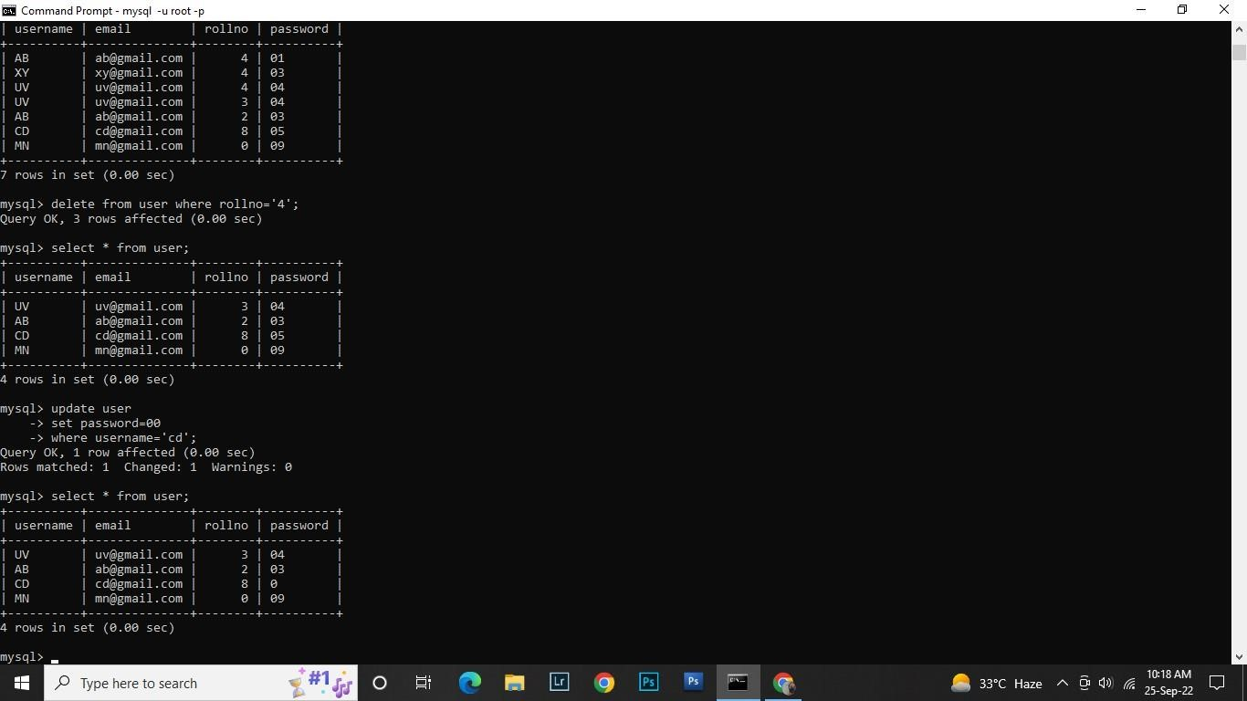

**CREATE TABLE:**

**CREATE TABLE Student (Username varchar (20), email varchar (20), roll number int(15),password varchar(30));**

**INSERT QUERY:**

**Insert into Student values (‘uv’, ‘uv@gmail.com’,’3’,’04’); Insert into Student values (‘AB’, ‘AB@gmail.com’,’2’,’03’);**

**Insert into Student values (‘CD’, ‘CD@gmail.com’,’8’,’05’); Insert into Student values (‘MN’, ‘MN@gmail.com’,’0’,’09’);**

**2.perform UPDATE DELETE queries with user table?**

**QUERY:**

**UPDATE:**

**Update Student set password=00 where username =’CD’;**

**DELETE:**

**Delete from user where roll no =’4’;**



**3.Connect Python code to db2?**

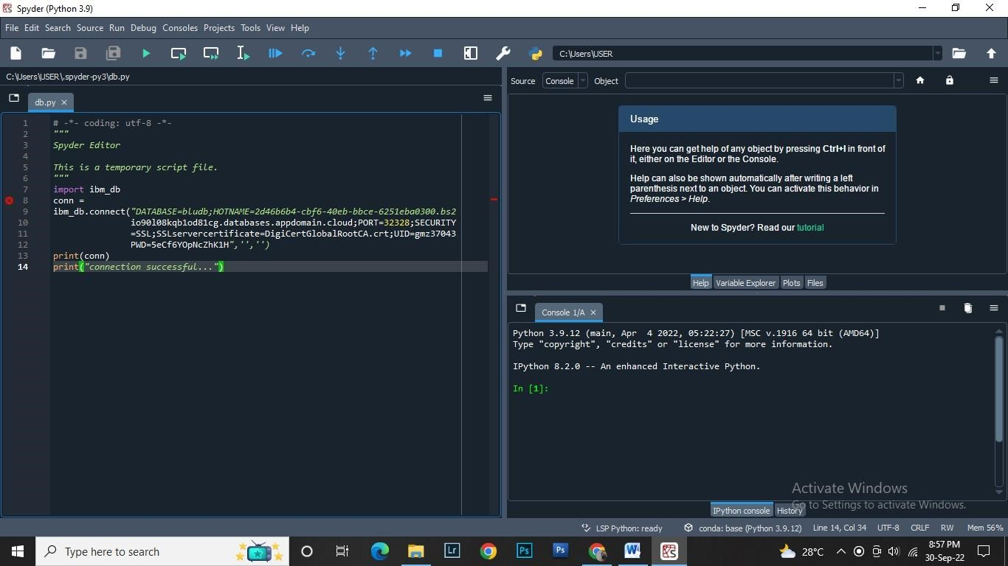

**Question no.4: Create a flask app with registration page login page and welcome page.?**

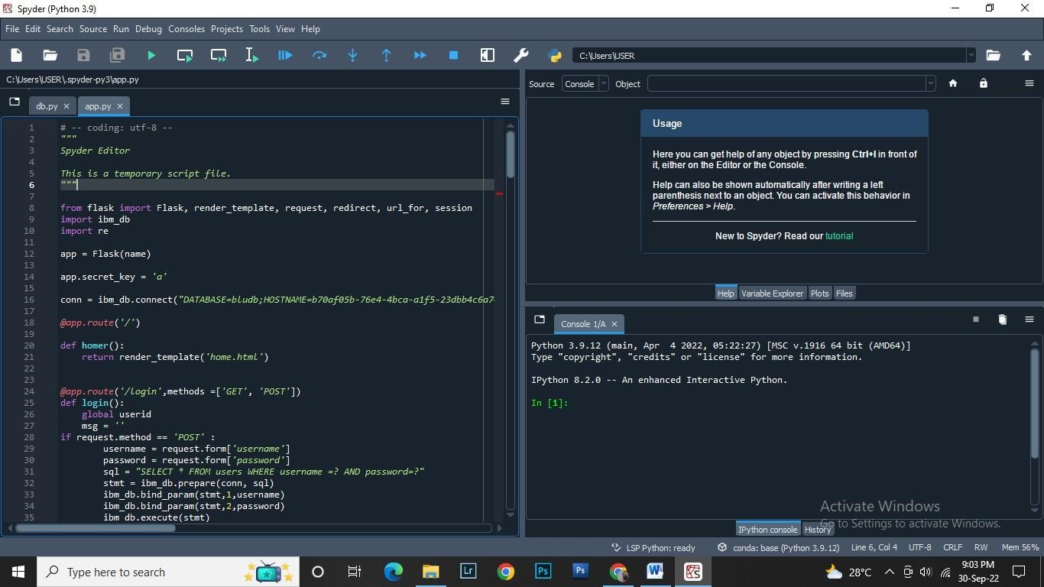

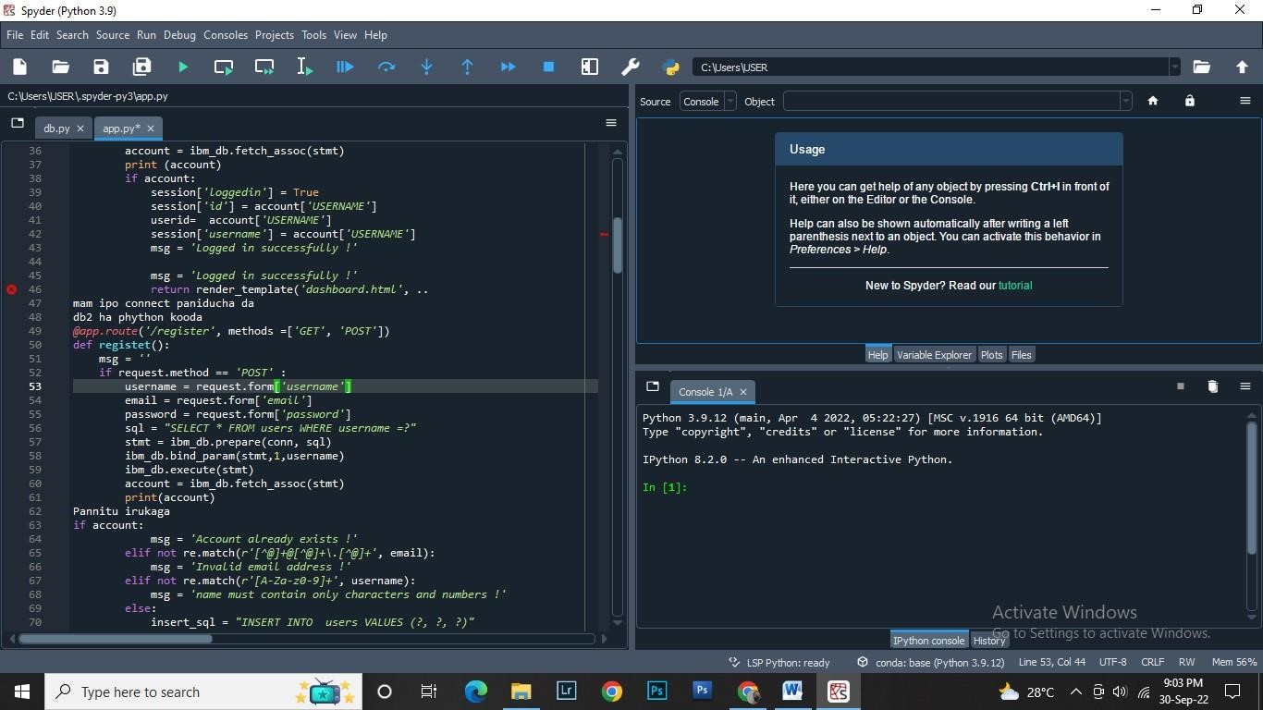

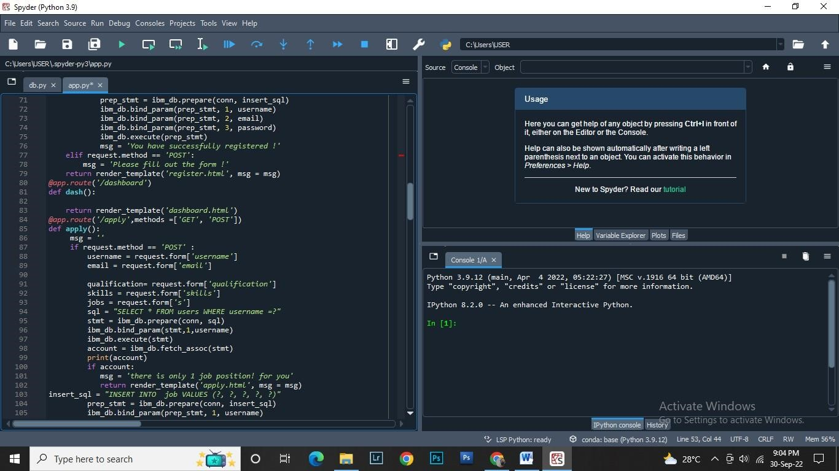

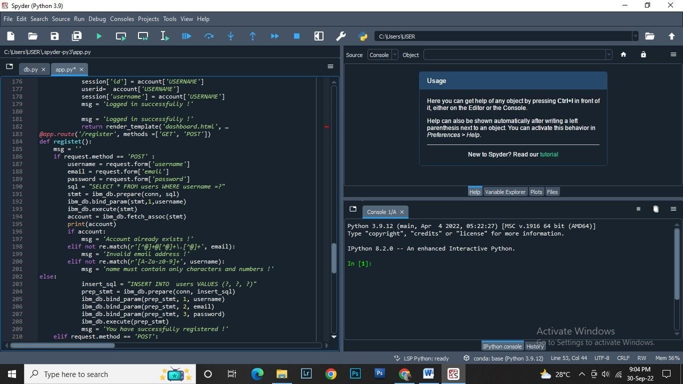

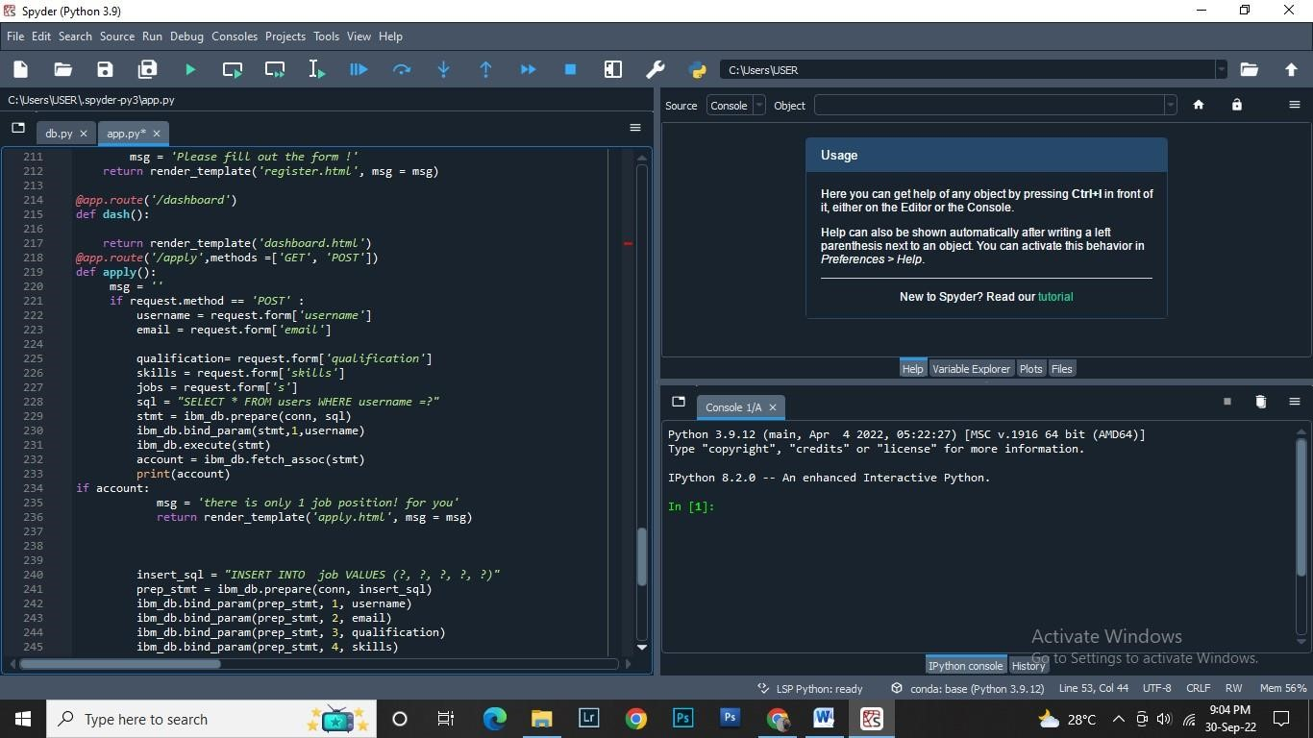

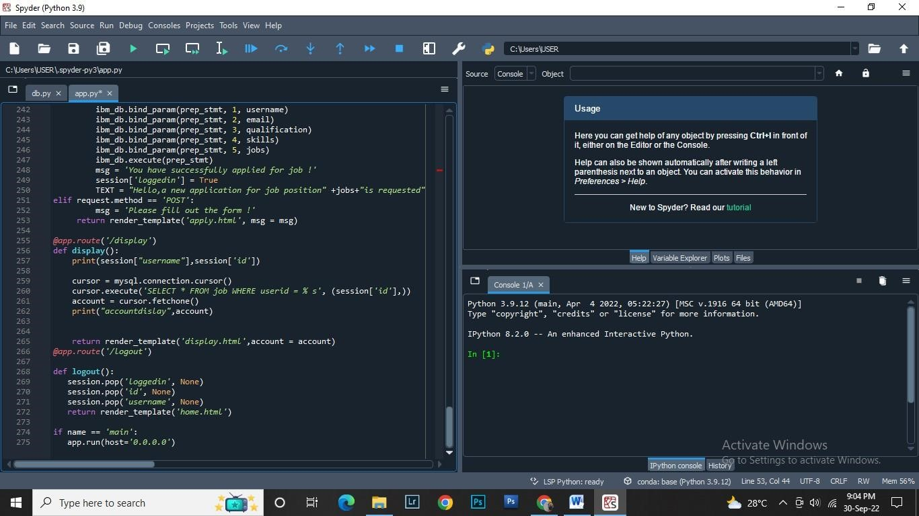

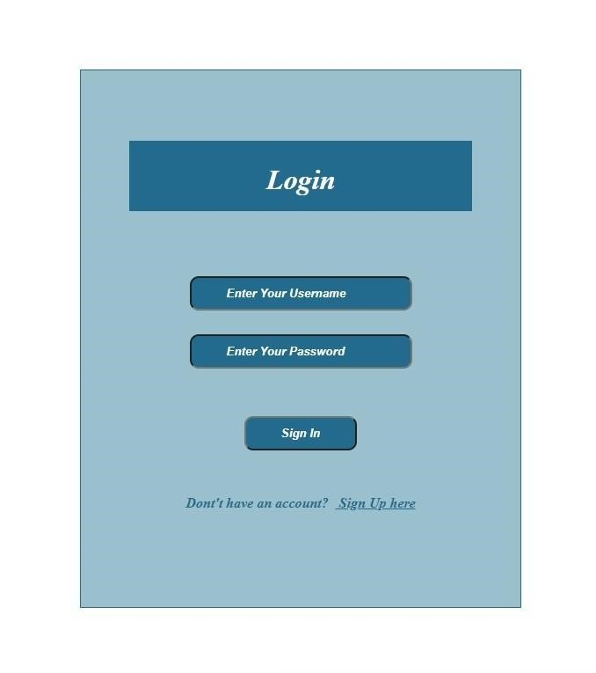

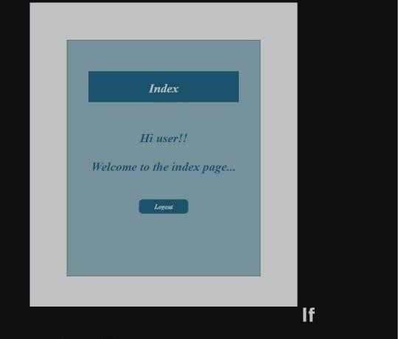

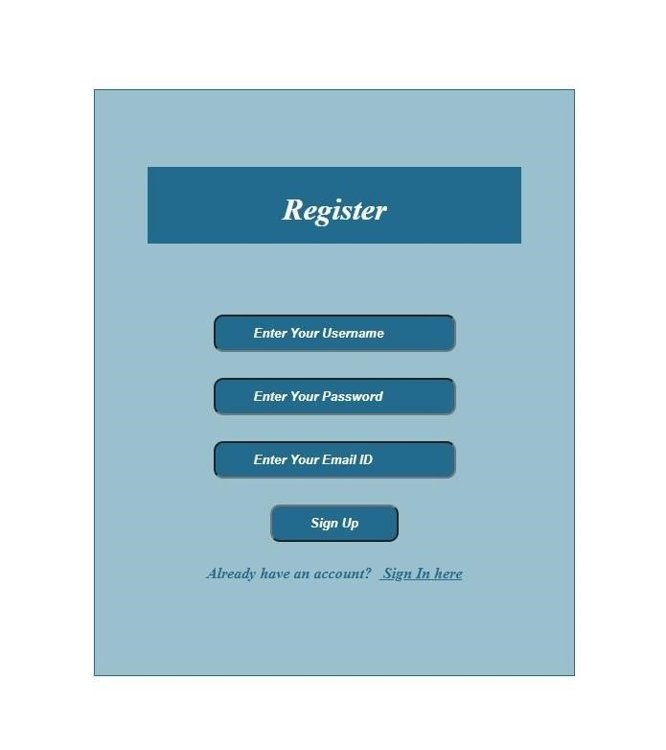

{% extends "bootstrap_responsive.html" %}

{% import "bootstrap_wtf.html" as wtf %}

{% block body_content %}

<div class="container-fluid">

{% block container %}

{% endblock %}

</div>

{% endblock %}

{% extends "base_layout.html" %}

{% block container %}

<div class="row-fluid">

<div class="span12">

<h1>Login</h1>

<form class="form form-horizontal" action="{{ url_for_security('login') }}" method="POST" name="login_user_form">

{{ login_user_form.hidden_tag() }}

{{ wtf.horizontal_field(login_user_form.email) }}

{{ wtf.horizontal_field(login_user_form.password) }}

{{ wtf.horizontal_field(login_user_form.remember) }}

<div class="controls">

<button class="btn btn-primary" type="submit">Login</button>

</div>

</form>

</div>

</div>

{% endblock %}

{% extends "base_layout.html" %}

{% block container %}

<div class="row-fluid">

<div class="span12">

<h1>Register</h1>

<form class="form form-horizontal" action="{{ url_for_security('register') }}" method="POST" name="register_user_form">

{{ register_user_form.hidden_tag() }}

{{ wtf.horizontal_field(register_user_form.email) }}

{{ wtf.horizontal_field(register_user_form.password) }}

{% if register_user_form.password_confirm %}

{{ wtf.horizontal_field(register_user_form.password_confirm) }}

{% endif %}

<div class="controls">

<button class="btn btn-primary" type="submit">Register</button>

</div>

</form>

</div>

</div>

{% endblock %}